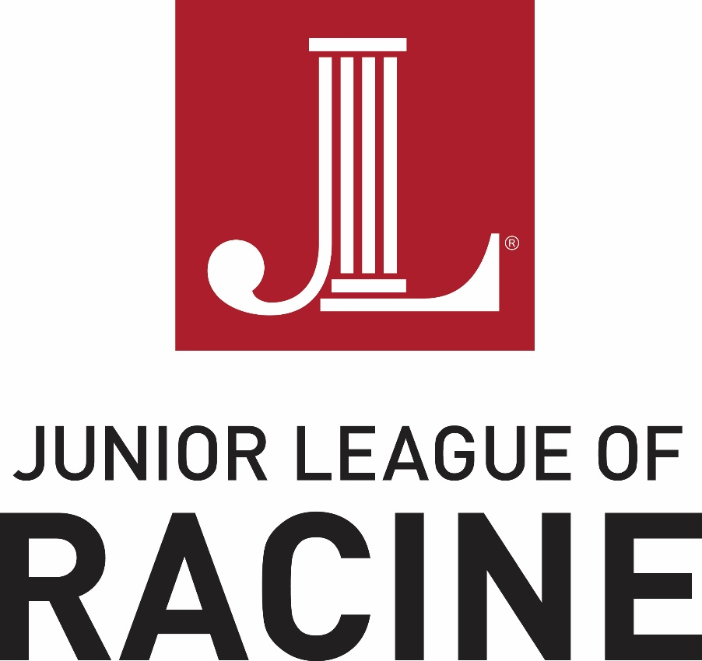
Style and Branding Guide

We are pleased to provide the Junior League of Racine members with this style and branding guide. It is designed to help league members present a unified message and appearance in all publications.

While the following standards and guidelines are meant to be comprehensive there may be situations that the following guide does not anticipate. The Junior League of Racine reserves the right to change the standards and guidelines as necessary to protect the brand. If you have any questions about this manual please e-mail or call the Communication Chair for further clarification.

IDENTITY
A NAME CAN SPEAK VOLUMES.
The Junior League brand identity is communicated on a high level by our name, and those of our Leagues. There’s a specific way The Junior League name should be featured in layout—as well as how it should appear for local Leagues.

International Name
As body text, the international name should be featured as “The Junior League” with a capital “T” on “The.” The role of “The Junior League” brand is the outward expression of an international alliance structure, and the “The” is reserved for the organizational brand as a whole, representing all 291 individual Leagues. In layout, it should be featured as seen.

The Association
Featured in body text as “The Association of Junior Leagues International” with a capital “T” on “The.” The name can be abbreviated as “AJLI,” in all caps, after the first occurrence of the full name. When referencing the Association with its acronym we do not use “The AJLI,” we simply say “AJLI.” While The Association of Junior Leagues International, Inc, is the Association’s legal name, and is used in invoices, contracts, tax returns, legal documents and so on, the “Inc.” is not necessary in the logo.
In layout, the full name and abbreviation should be featured as seen here.

LOGO
A MEMORABLE MARK THAT EMBODIES STRENGTH, CONSTANCY AND STABILITY.
The combination marks combine the JL icon with the League name. Select the version that best suits the design of the materials you are producing.

PRIMARY

Combo Stacked
This is the preferred lockup because it recognizes the League as part of a larger association while emphasizing the power of the local name.

SECONDARY COMBOS

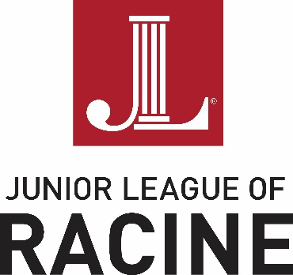

Combo Stacked Centered
To be used when design of the piece requires centered alignment

Combo
Recommended with League names up to 12 characters only

Horizontal Wordmark
The wordmark can be used when there are enough design elements in the piece to help it distinguish itself as belonging to our brand.

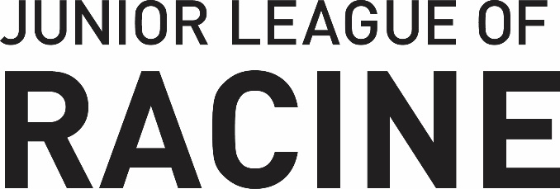

Stacked Wordmark
The wordmark can be used when there are enough design elements in the piece to help it distinguish itself as belonging to our brand.

Alternate Logo Styles
There are occasions when an alternative to the standard logo may be more appropriate.
The all black version is useful in designs that are solely black and white.
The white drop-out version (shown here on a grey background) is useful for designs on a color background, such as a t-shirt or tote-bag.

DON’TS

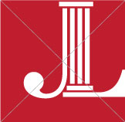
Do not change the position of the JL in the box

Do not reproduce in an unapproved color

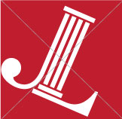
Do not rotate or animate the JL

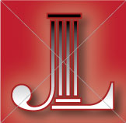
Do not add special effects such as drop shadows, reflections, glows,gradients or extra strokes

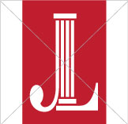
Do not distort, should always be proportional

Don’t reconfigure or change the size or placement of any logo elements

Do not use low-quality/low-resolution logo files

Do not place against a “busy” background that compromises its visibility

TRADEMARK
A TRADEMARK THAT REFLECTS OUR PRIDE, COMMITMENT AND HERITAGE.

Our brand is a valuable asset, and therefore its trademark must be protected. Our trademark is registered and should be displayed with the appropriate symbol.
In print, the registration mark ® should be properly noted the first time the name is used in a document, like a press release or article, or anywhere else our trademark and copyright notice does not appear.
Here’s how to indicate our trademark in writing:
Include the ® symbol in the upper right-hand corner, above the word:
The Junior League®
The Association of Junior Leagues International®
Junior League of Name®
The JL icon should always have the ®. There are times when using the icon at a smaller size will make the ® symbol illegible, and therefore may be removed.

Primary Typeface

FF DIN is The Junior League’s primary typeface. This is used for the logo and wordmark, and all print communications and merchandise. FF DIN is the more polished form of it’s historical predecessor—DIN 1451. Introduced in 1905, DIN 1451 has been the standard typeface for road signage and traffic signs in Germany since the 1930s. A balanced, legible, contemporary typeface, FF DIN is celebrated for being clean, modern, bold and striking—yet neutral enough to be objective bearer of information.

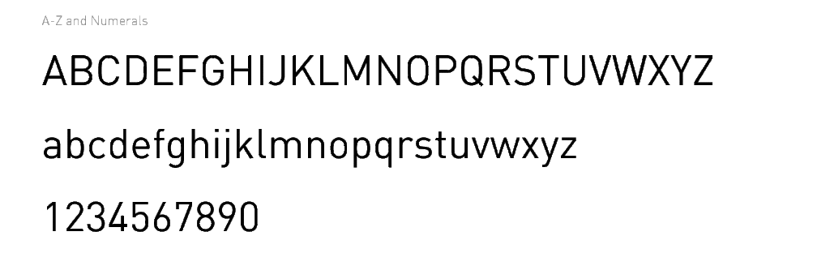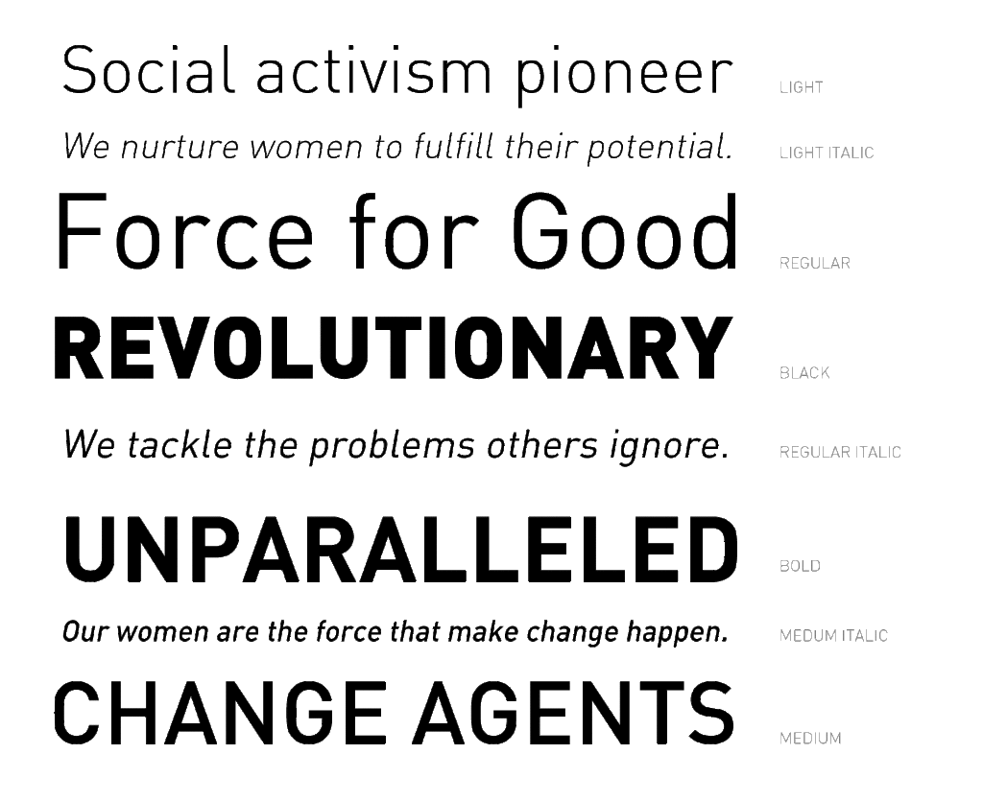

The Junior League uses FF Din 1 and FF Din 2 families. They contain five font weights plus italic versions for each. Combine font weights in a way that visually separates different textual elements like headlines, sub-headlines, body copy, and captions. Plan carefully to create visual contrast and accentuate the content hierarchy.

Secondary Typeface
Museo Sans is The Junior League’s secondary typeface—used for the Web or for materials meant to be read online, such as PDFs. Museo is a sturdy, low-contrast, highly legible sans-serif typeface well suited for any display or text use. It includes 5 weight styles with italic versions for each. Museo should never be used as a replacement for DIN in the logo or wordmark.

Arial
Arial typeface is an acceptable stand in only when DIN or Museo are unavailable. Arial may be used in PowerPoint presentations as well. However, it should never be used as a replacement for DIN in the logo or wordmark.

COLOR
THE COLOR OF PASSION AND LEADERSHIP.
JL Red is one of our distinguishing features and is an essential part of our brand identity. When combined with white, dark grey and black, a distinct style is created that is both easy to use and powerful in its simplicity.

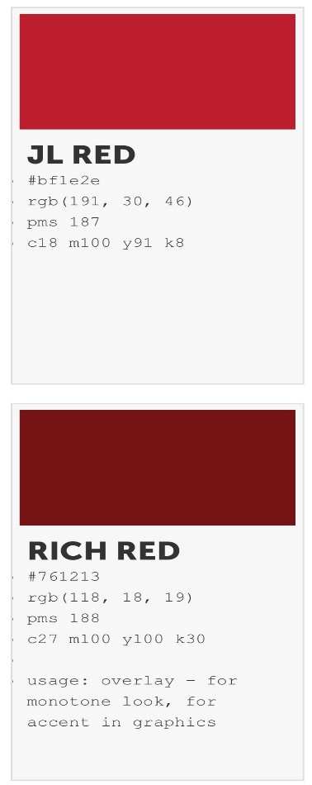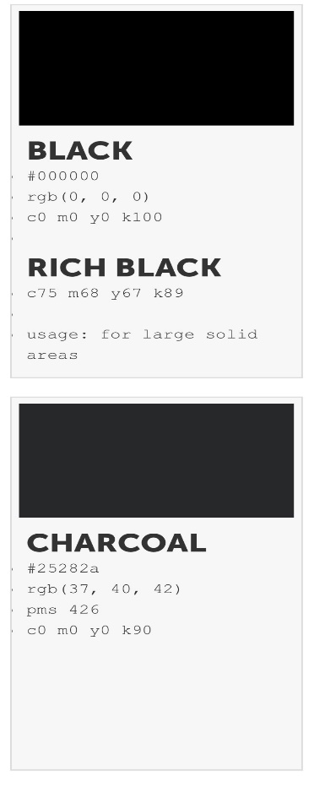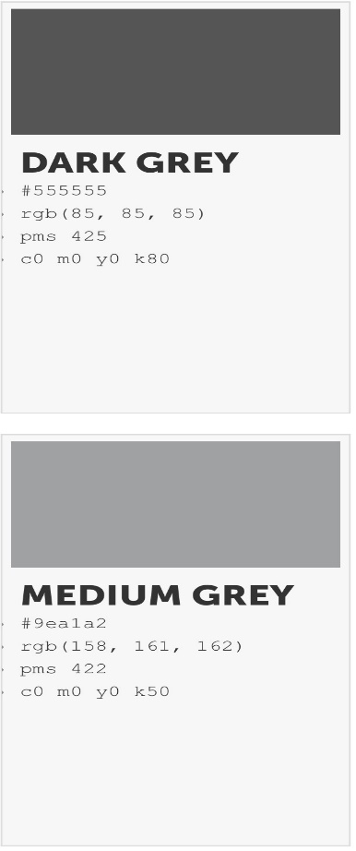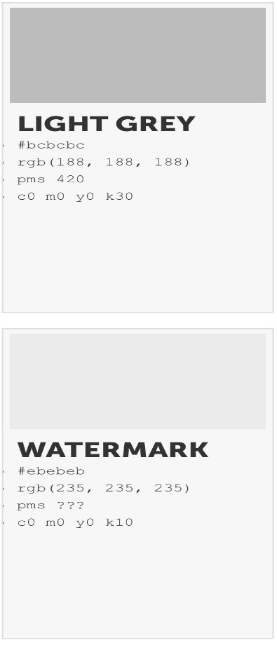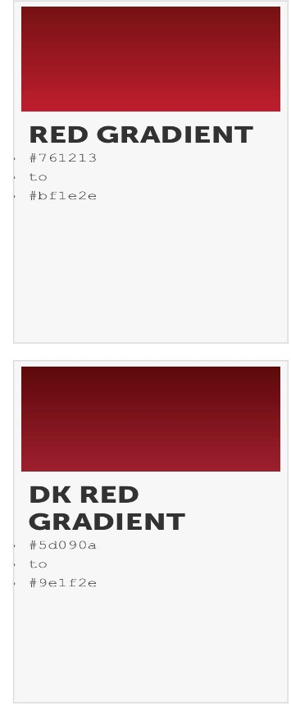

Usage
It is important that every JL design utilize the JL Red brand color. While it does not have to be the primary focus of the piece, it should be visible somewhere in the composition.
Use JL Red to emphasize, accentuate and lend priority. By using it in smaller increments against a white background, the color becomes more pronounced and proud. If a piece is predominantly JL Red, go with a monochromatic approach, using white type.
The logo may be placed on other background colors. In those cases, the logo should appear in white. Maintain contrast between the background and the logo to ensure legibility.

PATTERN
THERE’S POWER IN NUMBERS.
Two of our patterns reference the logo block. By using the shape in a pattern, it suggests the power of our Association and the multiplying effect we have in communities. Colors can be reversed and combinations changed. For help, contact communications@ajli.org.

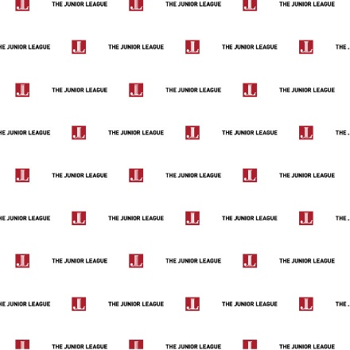
Step & Repeat Dense Tonal Grid
Airy Twinkle Parallax Women

For more information and resources on JLR Style and Branding can be found by signing into the member’s area on the AJLI website.

